## ASSIGNMENT 05

**FALL 2022**

**EMBEDDED SYSTEMS**

Submitted by : **SHAHZADA FAHIM JAN**

Registration no: **19PWCSE1765**

Semester**: 7th**

Section : **A**

“On my honor, as student of University of Engineering and Technology, I have neither given nor received unauthorized assistance on this academic work.”

Student signature

Submitted to:

**Dr. BILAL HABIB**

**JANUARY 13 2023**

**Department of Computer Systems Engineering**

**University of Engineering and Technology, Peshawar**

## Q No 01:

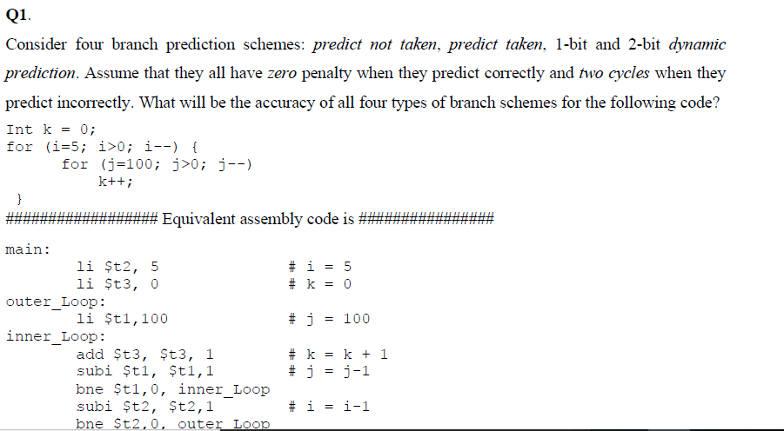

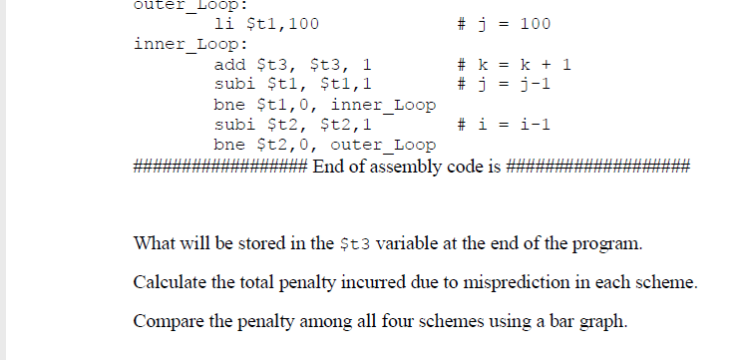

## ANSWER:

**Predict not taken:**

**Outer loop:**

Int k = 0;

for (i=5; i>0; i--) {

}

Total Instructions= 5

**Mispredictions =5 *0.53=2.65**

**Penalty=2.65 *2cycles = 5.3 cycles**

**Inner loop:**

for(j=100;j>0;j--)

Total Instructions= 505

**Mispredictions =505 *0.53= 267.65**

**Penalty= 267.65*2cycles = 535.3cycles**

Average penalty=(**535.3+5.3)/2=270.3cycles**

**Predict taken:**

**Outer loop:**

Int k = 0;

for (i=5; i>0; i--) {

}

Total Instructions= 5

**Mispredictions =5 *0.47=** **2.35**

**Penalty=2.35*2cycles = 4.7 cycles**

**Inner loop:**

for(j=100;j>0;j--)

Total Instructions= 505

**Mispredictions =505 *0.47= 237.35**

**Penalty= 237.35*2cycles = 474.7cycles**

Average penalty=(**474.7+2.35)/2=238.525 cycles**

**1 bit prediction:**

**Outer loop:**

**Branch Not Taken:**

|  |  |  |  |  |  |  |  |  |  |  |  |  |  |  |  |  |  |  |  |  |  |  |  |  |  |
| --- | --- | --- | --- | --- | --- | --- | --- | --- | --- | --- | --- | --- | --- | --- | --- | --- | --- | --- | --- | --- | --- | --- | --- | --- | --- |
| **Actual** | **T** | **T** | **T** | **T** | **NT** | **T** | **T** | **T** | **T** | **NT** | **T** | **T** | **T** | **T** | **NT** | **T** | **T** | **T** | **T** | **NT** | **T** | **T** | **T** | **T** | **NT** |
| **\Predict** | **NT** | **T** | **T** | **T** | **T** | **NT** | **T** | **T** | **T** | **T** | **NT** | **T** | **T** | **T** | **T** | **NT** | **T** | **T** | **T** | **T** | **NT** | **T** | **T** | **T** | **T** |

**Accuracy= 15/25*100 =0.6 = 60% , Not Taken =10**

**Penalty: 10*2cycles= 20 cycles**

**1 bit prediction:**

**Branch Taken:**

|  |  |  |  |  |  |  |  |  |  |  |  |  |  |  |  |  |  |  |  |  |  |  |  |  |  |
| --- | --- | --- | --- | --- | --- | --- | --- | --- | --- | --- | --- | --- | --- | --- | --- | --- | --- | --- | --- | --- | --- | --- | --- | --- | --- |
| **Actual** | **T** | **T** | **T** | **T** | **NT** | **T** | **T** | **T** | **T** | **NT** | **T** | **T** | **T** | **T** | **NT** | **T** | **T** | **T** | **T** | **NT** | **T** | **T** | **T** | **T** | **NT** |
| **\Predict** | **T** | **T** | **T** | **T** | **T** | **NT** | **T** | **T** | **T** | **T** | **NT** | **T** | **T** | **T** | **T** | **NT** | **T** | **T** | **T** | **T** | **NT** | **T** | **T** | **T** | **T** |

**Accuracy= 16/25*100 =0.6 = 64% , Not Taken =9**

**Penalty: 9*2cycles= 18 cycles**

**1 bit prediction:**

**Inner loop:**

**Branch Not Taken:**

|  |  |  |  |  |  |  |  |  |  |  |  |  |  |  |  |  |  |  |  |  |  |  |  |  |  |
| --- | --- | --- | --- | --- | --- | --- | --- | --- | --- | --- | --- | --- | --- | --- | --- | --- | --- | --- | --- | --- | --- | --- | --- | --- | --- |
| **Actual** | **T** | **T** | **T** | **T** | **NT** | **T** | **T** | **T** | **T** | **NT** | **T** | **T** | **T** | **T** | **NT** | **T** | **T** | **T** | **T** | **NT** | **T** | **T** | **T** | **T** | **NT** |
| **\Predict** | **NT** | **T** | **T** | **T** | **T** | **NT** | **T** | **T** | **T** | **T** | **NT** | **T** | **T** | **T** | **T** | **NT** | **T** | **T** | **T** | **T** | **NT** | **T** | **T** | **T** | **T** |

**Accuracy= 495/505*100 =0.98 = 98% , Not Taken =10**

**Penalty: 10*2cycles= 20 cycles**

**1 bit prediction:**

**Branch Taken:**

|  |  |  |  |  |  |  |  |  |  |  |  |  |  |  |  |  |  |  |  |  |  |  |  |  |  |
| --- | --- | --- | --- | --- | --- | --- | --- | --- | --- | --- | --- | --- | --- | --- | --- | --- | --- | --- | --- | --- | --- | --- | --- | --- | --- |
| **Actual** | **T** | **T** | **T** | **T** | **NT** | **T** | **T** | **T** | **T** | **NT** | **T** | **T** | **T** | **T** | **NT** | **T** | **T** | **T** | **T** | **NT** | **T** | **T** | **T** | **T** | **NT** |
| **\Predict** | **T** | **T** | **T** | **T** | **T** | **NT** | **T** | **T** | **T** | **T** | **NT** | **T** | **T** | **T** | **T** | **NT** | **T** | **T** | **T** | **T** | **NT** | **T** | **T** | **T** | **T** |

**Accuracy= 496/505*100 =0.6 = 98.21% , Not Taken =9**

**Penalty: 9*2cycles= 18 cycles**

**2 bit prediction:**

**Branch not taken:**

**Outer loop:**

**Branch not Taken:**

|  |  |  |  |  |  |  |  |  |  |  |  |  |  |  |  |  |  |  |  |  |  |  |  |  |  |
| --- | --- | --- | --- | --- | --- | --- | --- | --- | --- | --- | --- | --- | --- | --- | --- | --- | --- | --- | --- | --- | --- | --- | --- | --- | --- |
| **Actual** | **ST** | **ST** | **ST** | **ST** | **NT** | **ST** | **ST** | **ST** | **ST** | **NT** | **ST** | **ST** | **ST** | **ST** | **NT** | **ST** | **ST** | **ST** | **ST** | **NT** | **ST** | **ST** | **ST** | **ST** | **NT** |
| **\Predict** | **SNT** | **WNT** | **WT** | **ST** | **ST** | **WT** | **ST** | **ST** | **ST** | **ST** | **WT** | **ST** | **ST** | **ST** | **ST** | **WT** | **ST** | **ST** | **ST** | **ST** | **WT** | **ST** | **ST** | **ST** | **ST** |

**Accuracy = 18/25 = 0.72= 72% , Not Taken =7**

**Penalty: 7*2cycles= 14 cycles**

**Branch taken:**

|  |  |  |  |  |  |  |  |  |  |  |  |  |  |  |  |  |  |  |  |  |  |  |  |  |  |
| --- | --- | --- | --- | --- | --- | --- | --- | --- | --- | --- | --- | --- | --- | --- | --- | --- | --- | --- | --- | --- | --- | --- | --- | --- | --- |
| **Actual** | **ST** | **ST** | **ST** | **ST** | **NT** | **WT** | **ST** | **ST** | **ST** | **NT** | **WT** | **ST** | **ST** | **ST** | **NT** | **WT** | **ST** | **ST** | **ST** | **NT** | **WT** | **ST** | **ST** | **ST** | **NT** |
| **\Predict** | **ST** | **ST** | **ST** | **ST** | **ST** | **WT** | **ST** | **ST** | **ST** | **ST** | **WT** | **ST** | **ST** | **ST** | **ST** | **WT** | **ST** | **ST** | **ST** | **ST** | **WT** | **ST** | **ST** | **ST** | **ST** |

**Accuracy = 20/25 = 0.8= 80% , Not Taken =5**

**Penalty: 5*2cycles= 10 cycles**

**Inner loop:**

**For(j=100; j>0; j--){}**

**Branch not Taken:**

|  |  |  |  |  |  |  |  |  |  |  |  |  |  |  |  |  |  |  |  |  |  |  |  |  |  |
| --- | --- | --- | --- | --- | --- | --- | --- | --- | --- | --- | --- | --- | --- | --- | --- | --- | --- | --- | --- | --- | --- | --- | --- | --- | --- |
| **Actual** | **ST** | **ST** | **ST** | **ST** | **NT** | **ST** | **ST** | **ST** | **ST** | **NT** | **ST** | **ST** | **ST** | **ST** | **NT** | **ST** | **ST** | **ST** | **ST** | **NT** | **ST** | **ST** | **ST** | **ST** | **NT** |
| **\Predict** | **SNT** | **WNT** | **WT** | **ST** | **ST** | **WT** | **ST** | **ST** | **ST** | **ST** | **WT** | **ST** | **ST** | **ST** | **ST** | **WT** | **ST** | **ST** | **ST** | **ST** | **WT** | **ST** | **ST** | **ST** | **ST** |

**Accuracy = 498/505 = 98.61% , Not Taken =7**

**Penalty: 7*2cycles= 14 cycles**

**Branch taken:**

|  |  |  |  |  |  |  |  |  |  |  |  |  |  |  |  |  |  |  |  |  |  |  |  |  |  |
| --- | --- | --- | --- | --- | --- | --- | --- | --- | --- | --- | --- | --- | --- | --- | --- | --- | --- | --- | --- | --- | --- | --- | --- | --- | --- |
| **Actual** | **ST** | **ST** | **ST** | **ST** | **NT** | **WT** | **ST** | **ST** | **ST** | **NT** | **WT** | **ST** | **ST** | **ST** | **NT** | **WT** | **ST** | **ST** | **ST** | **NT** | **WT** | **ST** | **ST** | **ST** | **NT** |
| **\Predict** | **ST** | **ST** | **ST** | **ST** | **ST** | **WT** | **ST** | **ST** | **ST** | **ST** | **WT** | **ST** | **ST** | **ST** | **ST** | **WT** | **ST** | **ST** | **ST** | **ST** | **WT** | **ST** | **ST** | **ST** | **ST** |

**Accuracy = 500/505 =** **99.009% , Not Taken =5**

**Penalty: 5*2cycles= 10 cycles**

## Q No 02:

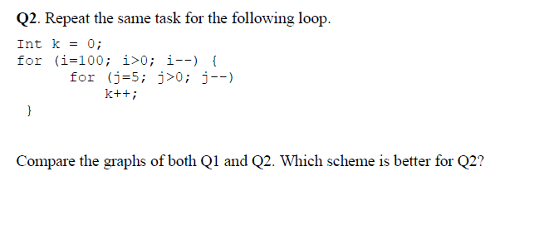

## ANSWER:

**1 bit prediction:**

**Outer loop:**

**Branch Not Taken:**

|  |  |  |  |  |  |  |  |  |  |  |  |  |  |  |  |  |  |  |  |  |
| --- | --- | --- | --- | --- | --- | --- | --- | --- | --- | --- | --- | --- | --- | --- | --- | --- | --- | --- | --- | --- |
| **Actual** | **T** | **T** | **T** | **T** | **T** | **T** | **T** | **T** | **T** | **T** | **T** | **T** | **T** | **T** | **T** | **T** | **T** | **T** | **…** | **NT** |
| **Predict** | **NT** | **T** | **T** | **T** | **T** | **T** | **T** | **T** | **T** | **T** | **T** | **T** | **T** | **T** | **T** | **T** | **T** | **T** | **…** | **T** |

**Total Instructions: 101**

**Not Taken =2**

**Accuracy= 99/10= 98.01%**

**Penalty: 2*2cycles= 4cycles**

**Branch taken:**

|  |  |  |  |  |  |  |  |  |  |  |  |  |  |  |  |  |  |  |  |  |  |  |
| --- | --- | --- | --- | --- | --- | --- | --- | --- | --- | --- | --- | --- | --- | --- | --- | --- | --- | --- | --- | --- | --- | --- |
| **Actual** | **T** | **T** | **T** | **T** | **T** | **T** | **T** | **T** | **T** | **T** | **T** | **T** | **T** | **T** | **T** | **T** | **T** | **T** | **T** | **T** | **…** | **NT** |
| **Predict** | **T** | **T** | **T** | **T** | **T** | **T** | **T** | **T** | **T** | **T** | **T** | **T** | **T** | **T** | **T** | **T** | **T** | **T** | **T** | **T** | **…** | **T** |

**Total Instructions: 101 , Branch Taken = 100**

**Not Taken =1**

**Accuracy=100/101=0.998 = 99.009%**

**Penalty: 1*2cycles= 2 cycles**

**Inner loop:**

**Branch Not Taken:**

|  |  |  |  |  |  |  |  |  |  |  |  |  |  |  |  |  |  |  |  |  |  |  |  |  |  |  |  |  |  |  |
| --- | --- | --- | --- | --- | --- | --- | --- | --- | --- | --- | --- | --- | --- | --- | --- | --- | --- | --- | --- | --- | --- | --- | --- | --- | --- | --- | --- | --- | --- | --- |
| **Actual** | **T** | **T** | **T** | **T** | **NT** | **T** | **T** | **T** | **T** | **NT** | **T** | **T** | **T** | **T** | **NT** | **T** | **T** | **T** | **T** | **NT** | **T** | | **T** | | **T** | | **T** | | **NT** | |
| **Predict** | **NT** | **T** | **T** | **T** | **T** | **NT** | **T** | **T** | **T** | **T** | **NT** | **T** | **T** | **T** | **T** | **NT** | **T** | **T** | **T** | **T** | **NT** | **T** | | **T** | | **T** | | **T** | |

**Accuracy= 300/505 = 59.60% , Not Taken =105**

**Penalty: 105*2cycles= 210 cycles**

**Branch Taken:**

|  |  |  |  |  |  |  |  |  |  |  |  |  |  |  |  |  |  |  |  |  |  |  |  |  |  |  |  |  |  |  |
| --- | --- | --- | --- | --- | --- | --- | --- | --- | --- | --- | --- | --- | --- | --- | --- | --- | --- | --- | --- | --- | --- | --- | --- | --- | --- | --- | --- | --- | --- | --- |
| **Actual** | **T** | **T** | **T** | **T** | **NT** | **T** | **T** | **T** | **T** | **NT** | **T** | **T** | **T** | **T** | **NT** | **T** | **T** | **T** | **T** | **NT** | **T** | | **T** | | **T** | | **T** | | **NT** | |
| **Predict** | **T** | **T** | **T** | **T** | **T** | **NT** | **T** | **T** | **T** | **T** | **NT** | **T** | **T** | **T** | **T** | **NT** | **T** | **T** | **T** | **T** | **NT** | **T** | | **T** | | **T** | | **T** | |

**Accuracy= 301/505 = 59% , Not Taken =105**

**Penalty: 104*2cycles= 210 cycles**

**2-Bit Predictor**

**Outer loop:**

**for(j=100;j>0;j--)**

**Branch Not Taken:**

|  |  |  |  |  |  |  |  |  |  |  |  |  |  |  |  |  |  |  |
| --- | --- | --- | --- | --- | --- | --- | --- | --- | --- | --- | --- | --- | --- | --- | --- | --- | --- | --- |
| **Predict** | **SNT** | **WNT** | **WT** | **ST** | **ST** | **ST** | **ST** | **ST** | **ST** | **ST** | **ST** | **ST** | **ST** | **ST** | **ST** | **ST** | **…** | **ST** |
| **Actual** | **ST** | **ST** | **ST** | **ST** | **ST** | **ST** | **ST** | **ST** | **ST** | **ST** | **ST** | **ST** | **ST** | **ST** | **ST** | **ST** | **…** | **NT** |

**Brach Taken: 98**

**Accuracy= 98/101= 97%**

**Penalty = 3*2cycles= 6 cycles**

**Branch Taken:**

|  |  |  |  |  |  |  |  |  |  |  |  |  |  |  |  |  |  |  |  |  |
| --- | --- | --- | --- | --- | --- | --- | --- | --- | --- | --- | --- | --- | --- | --- | --- | --- | --- | --- | --- | --- |
| **Predict** | **ST** | **ST** | **ST** | **ST** | **ST** | **ST** | **ST** | **ST** | **ST** | **ST** | **ST** | **ST** | **ST** | **ST** | **ST** | **ST** | **ST** | **ST** | **…** | **ST** |
| **Actual** | **ST** | **ST** | **ST** | **ST** | **ST** | **ST** | **ST** | **ST** | **ST** | **ST** | **ST** | **ST** | **ST** | **ST** | **ST** | **ST** | **ST** | **ST** | **…** | **NT** |

**Total Instructions:101, Branch Taken = 100**

**Not Taken =1**

**Accuracy=100/101=99.009%**

**Penalty: 1*2cycles= 2 cycles**

**Inner Loop:**

for(i=5;i>0;i--)

k++

**Branch Taken:**

|  |  |  |  |  |  |  |  |  |  |  |  |  |  |  |  |  |  |  |  |  |  |
| --- | --- | --- | --- | --- | --- | --- | --- | --- | --- | --- | --- | --- | --- | --- | --- | --- | --- | --- | --- | --- | --- |
| **Predict** | **ST** | **ST** | **ST** | **ST** | **ST** | **WT** | **ST** | **ST** | **ST** | **ST** | **WT** | **ST** | **ST** | **ST** | **ST** | **WT** | **ST** | **ST** | **ST** | **ST** | **…..** |
| **Actual** | **ST** | **ST** | **ST** | **ST** | **NT** | **ST** | **ST** | **ST** | **ST** | **NT** | **ST** | **ST** | **ST** | **ST** | **NT** | **ST** | **ST** | **ST** | **ST** | **NT** | **….** |

**Accuracy = 500/505 = 99.009% , Not Taken =5**

**Penalty: 5*2cycles= 10 cycles**

**Branch Not Taken:**

|  |  |  |  |  |  |  |  |  |  |  |  |  |  |  |  |  |  |  |  |  |  |
| --- | --- | --- | --- | --- | --- | --- | --- | --- | --- | --- | --- | --- | --- | --- | --- | --- | --- | --- | --- | --- | --- |
| **Predict** | **SNT** | **WNT** | **WT** | **ST** | **ST** | **WT** | **ST** | **ST** | **ST** | **ST** | **WT** | **ST** | **ST** | **ST** | **ST** | **WT** | **ST** | **ST** | **ST** | **ST** | **….** |
| **Actual** | **ST** | **ST** | **ST** | **ST** | **NT** | **ST** | **ST** | **ST** | **ST** | **NT** | **ST** | **ST** | **ST** | **ST** | **NT** | **ST** | **ST** | **ST** | **ST** | **NT** | **….** |

**Branch Taken: 2+ 4(99)= 398 , Not Taken =7**

**Accuracy = 498/505 =98% ,**

**Penalty: 7*2cycles= 14 cycles**

## Q No 03:

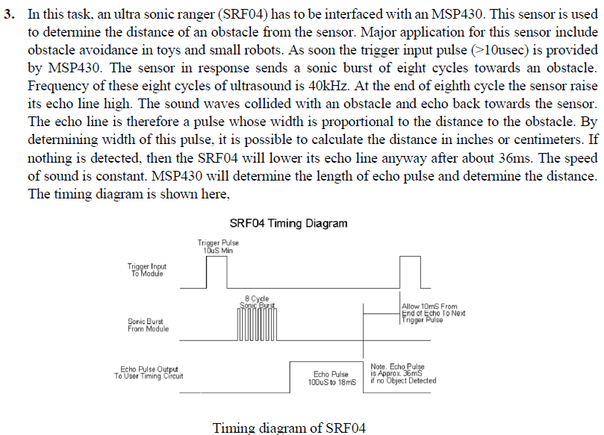

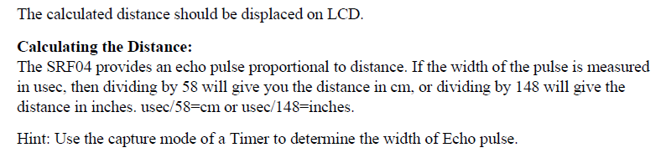

CODE:

/* Main.c file generated by New Project wizard

*

* Created: Fri Jan 13 2023

* Processor: MSP430F2418

* Compiler: GCC for MSP430

*/

#include <MSP430.h>

#include <stdint.h>

#define rs BIT6

#define e BIT7

#define buzz BIT0

//global variables

uint16_t OLD_TICKS= 0;

uint16_t NEW_TICKS = 0;

uint32_t NEW_TIME;

uint32_t OLD_TIME;

#pragma vector = TIMERA1_VECTOR //TIMERA1_VECTOR for TA0CCR1 and other channels

__interrupt void port_1(void)

{

NEW_TICKS = TA0CCR1-OLD_TICKS;

OLD_TICKS= TA0CCR1;

NEW_TIME = (uint32_t)((NEW_TICKS/58)+1);

if(NEW_TIME <=20)

P1OUT=BIT0;

else

P1OUT &=~BIT0;

TACCTL1 &= ~CCIFG;

__bic_SR_register_on_exit(LPM4_bits);

}

// Functions Definition

void delay(uint32_t a)

{

uint32_t i;

for(i=0;i<a;i++);

}

// to send data to LCD

void writedata(uint8_t t)

{

P7OUT |= rs; // This is our data

P8OUT = t; //Data transfer

P7OUT |= e;

delay(150);

P7OUT &= ~e;

delay(150);

}

// for writning command to LCD

void writecmd(uint8_t z)

{

P7OUT &= ~rs; // This is command

P8OUT = z; //Data transfer

P7OUT |= e; // => E = high

delay(150);

P7OUT &= ~e; // => E = low

delay(150);

}

// initialize the LCD

void lcdinit(void)

{

// Reset process from datasheet

delay(15000);

writecmd(0x30);

delay(4500);

writecmd(0x30);

delay(300);

writecmd(0x30);

delay(650);

writecmd(0x38); //function set

writecmd(0x0c); //display on,cursor off,blink off

writecmd(0x01); //clear display

writecmd(0x06); //entry mode, set increment

}

// return to 0 location on LCD

void Return(void) //Return to 0 location on LCD

{

writecmd(0x02);

delay(100);

}

int main (void)

{

BCSCTL1 = CALBC1_1MHZ; //calibration 1Mhz

DCOCTL = CALDCO_1MHZ;

P8DIR=0xFF; //output lines to LCD

P7DIR=e|rs;

P1DIR |=buzz;

P1DIR &= ~BIT2;

P1SEL |= BIT2; // Timer A recieves input signal from the SR Sensor

P4DIR |= BIT1; //Output

P4SEL |= BIT1; // MODULE 1 (MODULE 0 gpio

TA0CCTL1 |= CM_3 + CCIS_0 + SCS + CAP + CCIE; //Capture mode

//Recives signal from the sensor and increments its value till interrupt occurs

TA0CTL |= TASSEL_2 + MC_2 + TACLR;//Timer A Configuration

TB0CCR0 = 0xFFFF-1; //Timer Upper Limit

TB0CCR1 = 10; // 10 usec

TB0CCTL0 = TB0CCTL1 = OUTMOD_7;// //Reset/Set

TB0CTL = MC_1 + ID_0 + TBSSEL_2 + TBCLR; //Timer B

lcdinit();

while (1){

if(!(TA0CCTL1 & CCI))

{ // when signal comes to P1.2

Return();

if((NEW_TIME/100)%10==0)

{

}

else

{

writedata(((NEW_TIME/100)%10) + 48);

}

writedata(((NEW_TIME/10)%10) + 48);

writedata((NEW_TIME%10) + 48);

writedata(' ');

writedata('c');

writedata('m');

OLD_TIME = NEW_TIME; //updates time

}

__bis_SR_register(LPM4_bits + GIE);

}

return 0;

}

**OUTPUT:**

## CIRCUIT:

